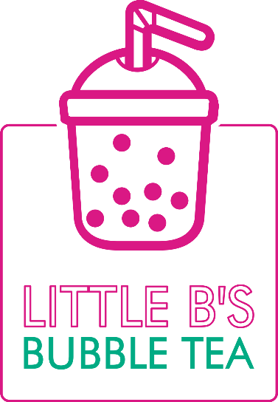
Little B’ Bubble Tea Price List
info@littlebs.co.za 0761392396

Bursting Boba 260ml R85
Nata de Coco 260ml R75
Tapioca 150g R45
Tapioca 300g R90
Tapioca 450g R135
Tapioca 600g R180
Tapioca 1000g R275
Brown Sugar Syrup 100ml R65
Brown Sugar Syrup 250ml R140
Milk Tea Powder 100g R65
Milk Tea Powder 250g R150
Fruit Syrups 100ml R65
Fruit Syrups 250ml R130
Rooibos Tea 30g R20
Rooibos Tea 60g R40
Green Tea 30g R20
Green Tea 60g R40
Black Tea 30g R20
Black Tea 60g R40
Oolong Tea 30g R20
Black Tea 60g R40
Fructose Syrup 100ml R30

Shaker R300
Glass Tea Infuser R80
Metal Straws 10mm R20
Plastic Straws 12mm .50c
Small Gift Box R400
Medium Gift Box R600
Large Gift Box R900
4 Drink Fruit Tea Box R350
8 Drink Fruit Tea Box R450
12 Drink Fruit Tea Box R550
4 Drink Milk Tea Box R350
8 Drink Milk Tea Box R450
12 Drink Milk Tea Box R550

